SPRINT 4

|  |  |
| --- | --- |
| Date | 13 november 2022 |
| Team ID | PNT2022TMID00922 |
| Project Name | Project – Signs with Smart Connectivity for Better Road Safety |

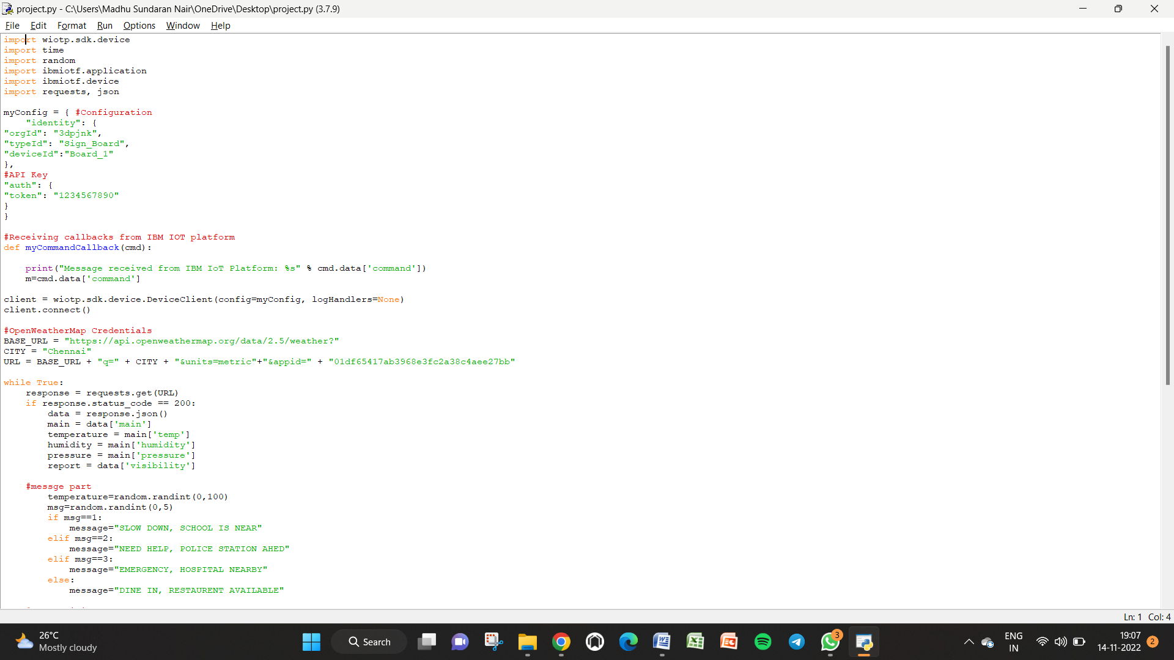

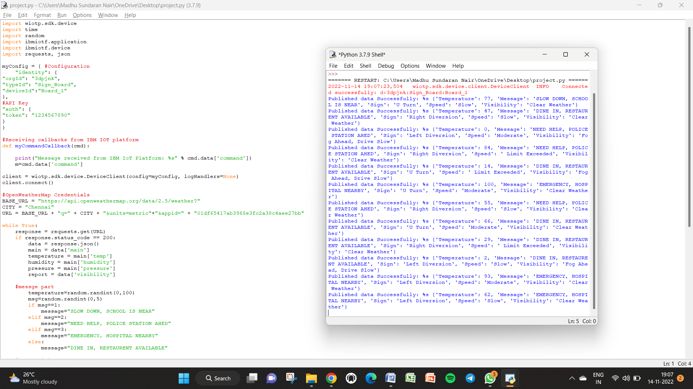

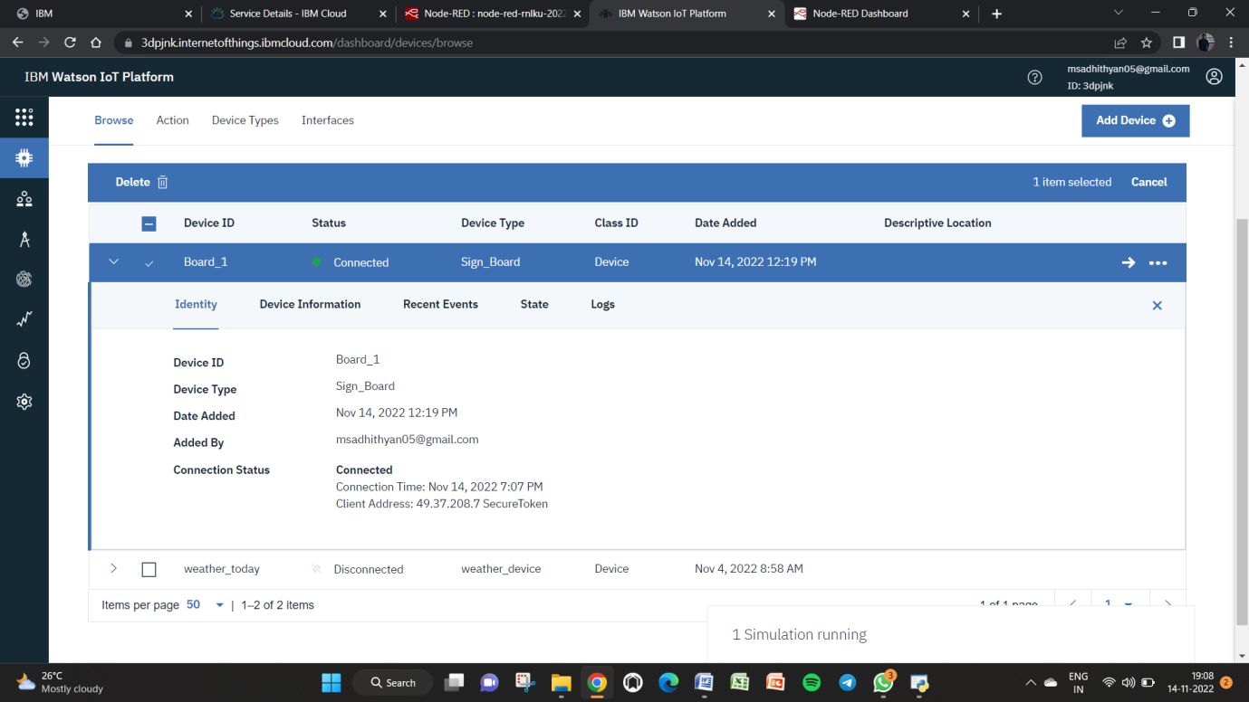

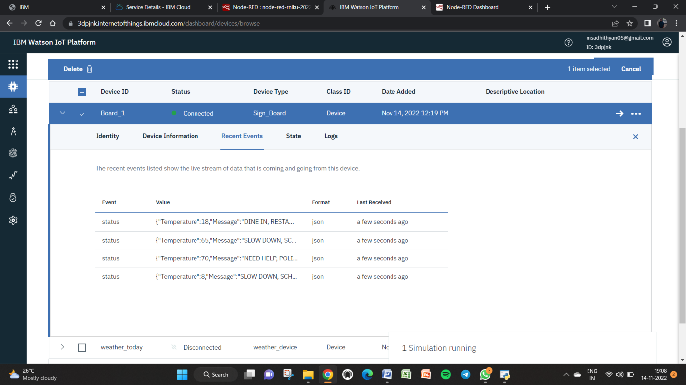

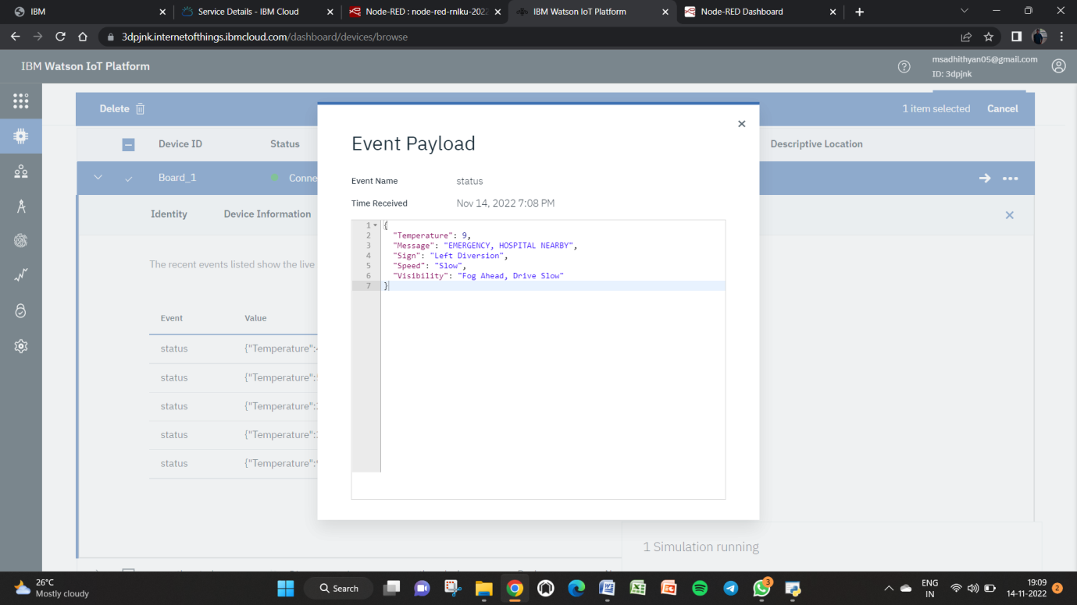

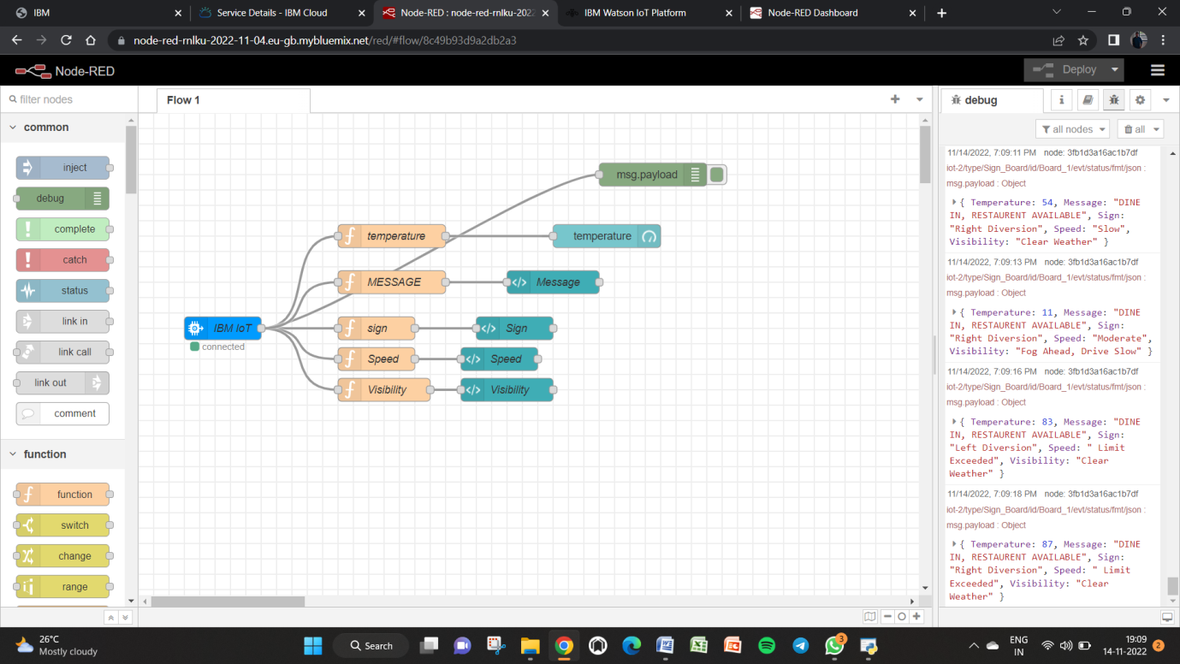

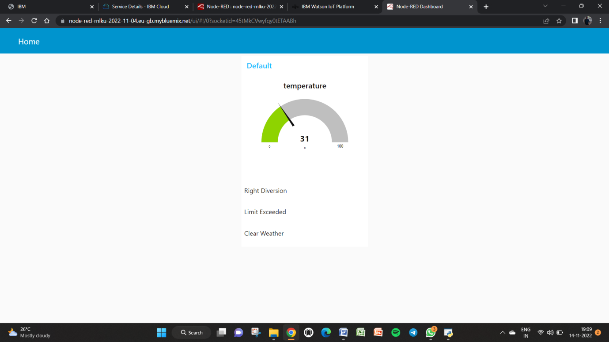

Node red : <https://node-red-rnlku-2022-11-04.eu-gb.mybluemix.net/ui/#!/0?socketid=45tMkCVwyfqy0tETAABh>